Computer Science Special Degree Research Project

**Smart Car Parking System**

Proposal Version 1.0

Department of Statistics & Computer Science

University of Kelaniya

Academic Year 2016/2017

By

Mr. P.M.D.S Amarasooriya

Submitted on:2019/04/06

Table of Contents

TITLE OF REASERCH PROJECT ……………………………………………………………………………………………… 2

INTRODUCTION ……………………………………………………………………………………………………………………  2

PROBLEM STATEMENT…………………………………………………………………………………………………………… 2

PROPOSED SOLUTION ……………………………………………………………………………………………………………  3

RESERCH AIMS AND OBJECTIVES ……………………………………………………………………………………………  3

METHODOLOGY ……………………………………………………………………………………………………………………. 4

HARDWARE AND SOFTEWARE REQUIMWNTS ………………………………………………………………………  4

GRANT CHAT  ………………………………………………………………………………………………………………………….  5

REFERENCES ………………………………………………………………………………………………………………………… 5

TITLE OF THE RESEARCH PROJECT

Smart Car Parking System

**INTRODUCTION**

Nowadays, the usage of vehicles is rapidly increasing So, Parking the car is one of the basic requirements necessary for a city. This has resulted in a steep increase in the sale of vehicles in the past decade. User parks their vehicle at a place where they feel its safety is optimum and nearest to its destination. The current status of the cities is the user has to spend an ample amount of time to find the spot which is both safe and near to his destination.

However, in the current parking system, a better but not an optimal solution is being provided.

**PROBLEM STATEMENT**

As we need to park our car manually and there is no discipline in this process it creates a huge hurdle. People can park theircars anywhere they want to, which creates a mess as people don’t follow a particular cue most of the time

As a result of this a huge traffic jam takes place in that place.

Also, there are numbers of cars came to a particular park at the same time, at that time one person can’t control all of these cars. He can’t find the empty spot immediately. Sometimes he can show some empty spot it can’t be the closest place.

Because of this reason,

* Valuable time wasted from inconvenient and inefficient parking lots

On average, 3.5 - 12 minutes spent waiting for a spot in urban parking

* Potential accidents caused by an abundance of moving vehicles in disorganized parking lots

PROPOSED SOLUTION

Here we are trying to build a suitable computerized Car Parking System.

When a car will come to the entrance the LCD display show the available nearest empty slot. In here we try to find the all empty spot and find the optimize path to

park the car.

The benefits of the proposedsystem can be given as follows:

* Reduce wastage of time
* Comfortable way of parking
* Efficiency
* Safety and Security

RESEARCH AIMS AND OBJECTIVES

Aim

The main aim are time and fuel saving. It can also provide sustainable parking management in an eco-friendly manner and reduce the huge traffic jam.

Objective

* To minimize the manual work
* To increase the efficiency of parking system
* To find out the economic benefits of introducing system
* To provide user friendly parking procedure
* To develop application for android platform
* To learn statistical methods for identify optimize path
* To learn how to identify the particular area given image
* To learn how to recognize shorted path using algorithms
* To enhanced my skills and knowledge

METHODOLOGY

* Agile methodology will be used to develop the system.

Agile Software Development is a set of methods and practices where solutions evolve through collaboration between self-organizing, cross-functional teams. In here I use Agile software development to develop this system. Agile SDLC model is a combination of iterative and incremental process. Because use this method I have to do same process iteratively. Use camera videos for to identify empty spot and gather the data. Try to establish the mathematical model find the optimize path. Also project can focus on high-quality development, testing. According to above factsAgile development is the most suitable methodology for develop this system.

HARDWARE AND SOFTWARE REQUIREMENTS

|  |  |  |
| --- | --- | --- |
|  | **Component** | **Minimum System Requirements** |
| Hardware Requirements | Processor | Intel Core i5 2.3GHz or higher |
| Memory | 8 GB or higher |
| Hard disk | 1 TB or higher |
| Power | Redundant suitable secondary Power source |
| Camera, Mobile Phone | |
| Software  Requirements | Operating System | Windows 10 |
| IDE | Spyder, Android Studio ,vs code |
| Application Platform | Java,python |

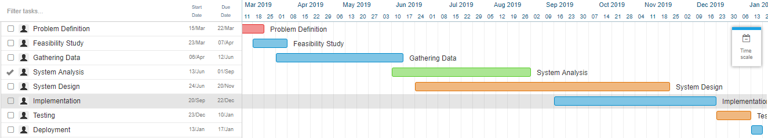**TIME LINE**

|  |  |  |
| --- | --- | --- |
| **Task Name** | **Start Date** | **End Date** |
| Problem Definition | 2019/03/15 | 2019/03/22 |
| Feasibility Study | 2019/30/23 | 2019/04/07 |
| Gathering Data | 2019/04/08 | 2019/05/12 |
| System Analysis | 2019/05/13 | 2019/07/01 |
| System Design | 2019/06/24 | 2019/11/20 |
| Implementation | 2019/09/20 | 2019/12/22 |
| Testing | 2019/12/23 | 2020/01/10 |
| Deployment | 2020/01/13 | 2020/01/17 |

REFERENCES

* Use for draw the gantt chart

<https://instagantt.com/r>

* Demo for car parking system

<https://www.dimolanka.com/storage-systems-material-handling/solutions/automated-car-parking-systems/>

* <https://www.youtube.com/watch?v=vZ08Y5aqdpM>
* Image processing

<https://sisu.ut.ee/imageprocessing/book/1>

* <https://riggaroo.co.za/building-a-custom-machine-learning-model-on-android-with-tensorflow-lite/>
* Agile development

<https://www.agilealliance.org/agile101/>